**A**

**Summer Training**

**On**

**Data Analytics**

Submitted in partial fulfilment of the requirements

for the award of the degree of

**Bachelor of Computer Applications**

To

Guru Gobind Singh Indraprastha University, Delhi



**Submitted By:**

Pranjal Tiwari :(03224402024)

Arshleen Kaur :( 09024402024)

Hritvi :( 03824402024)

Vansh Chandna:()

BCA-III

**Guide:** Mr. Prateek Gupta

**INSTITUTE OF INNOVATION TECHNOLOGY & MANAGEMENT**

**NEW DELHI-110058**

**Acknowledgement**

We are sincerely grateful to everyone who contributed to the successful completion of my summer training project.

First and foremost, we would like to express our heartfelt thanks to Mr. Prateek Gupta for his invaluable guidance and insightful support throughout the training. His expertise and patient mentorship played a vital role in helping me comprehend the complexities of advanced data science and machine learning.

We do also extend our sincere gratitude to IITM Janakpuri for partnering with Shape My Skills Pvt. Ltd. to offer such a remarkable learning opportunity. Special thanks to our course coordinator

Ms. Sushma Sethi, for her unwavering dedication and continuous support during the program. We are also deeply thankful to Dr. Geetali Banerjee, Head of the Department, for her encouragement and for providing the necessary resources and conducive environment for this enriching experience.

Lastly, We wholeheartedly appreciate the steadfast support of our family and friends, whose encouragement gave us strength throughout this journey.

Thank you all for making this experience both valuable and memorable.

Sincerely,

Pranjal Tiwari

Arshleen Kaur

Hritvi

Vansh Chandna

**Certificate**

This is to certify that Pranjal Tiwari, Arshleen Kaur, Hritvi, Vansh Chandna has successfully completed the project titled "Data Analytics" as part of the Machine Learning and Data Science summer training program organized by IITM Janakpuri in collaboration with ShapeMySkills Pvt. Ltd.

This project was conducted under the esteemed guidance of Mr. Prateek Gupta, whose

expertise and mentorship were instrumental in its successful completion. The project demonstrates a comprehensive understanding of data analytics concepts and techniques, showcasing the practical skills developed during the training program. We commend Pranjal Tiwari, Arshleen Kaur, Hritvi, Vansh Chandna for their dedication, hard work, and enthusiasm throughout the project duration.

Coordinator: Ms. Sushma Sethi

Head of Department: Dr. Geetali Banerjee

Date:

Signature:

**List Of Figures**

**S.No. Name Page**

1 Python Mini Projects 11

2 Numpy project 15

3 Panda project 19

4 Matplotlib Project 23

5 Seaborn Project 26

6 Powe BI Project 29-30

7 SQL Project 32

8 Excel 35

**Index**

**S.no. Title Page**

1. INTRODUCTION 6-8
2. PYTHON 9-12
3. PYTHON LIBRARIES 13-26
4. NUMPY 13-16
5. PANDAS 17-19
6. MATPLOTLIB 20-24
7. SEABORN 25-27
8. POWER BI 28-30
9. SQL 31-33
10. EXCEL 34-35
11. CONCLUSION 36-37

**Chapter 1:**

Introduction

**About Data Analytics**

Data Analytics is the science of examining raw data with the purpose of drawing meaningful insights and conclusions. It involves the use of specialized systems and software to process, transform, and analyze data, ultimately helping organizations make informed decisions. The rise of big data has amplified the need for proficient data analytics, making it a crucial discipline in the digital age.

**Importance in Modern Businesses**

Modern organizations rely heavily on data-driven decision-making to stay competitive. Data analytics enables businesses to:

* Identify trends and patterns
* Improve operational efficiency
* Target customers more effectively
* Innovate products and services
* Minimize risks and optimize resources

It plays a vital role in sectors such as finance, healthcare, marketing, retail, and technology, enhancing both strategic planning and daily operations.

**Key Stages: Data Collection, Cleaning, Analysis, and Visualization**

The data analytics workflow typically includes:

* Data Collection: Gathering relevant data from multiple sources such as databases, web platforms, IoT devices, and more.
* Data Cleaning: Preparing the data by handling missing values, removing duplicates, and correcting inconsistencies to ensure quality and reliability.
* Data Analysis: Applying statistical and computational methods to explore the data, test hypotheses, and extract insights.
* Data Visualization: Presenting the results through charts, graphs, dashboards, and reports to make insights accessible and actionable.

**Overview of Tools and Techniques (Python, Excel, Power BI, SQL, etc.)**

Data analytics utilizes a suite of powerful tools and technologies, including:

* Python: Popular for its rich ecosystem of libraries like Pandas, NumPy, Matplotlib, and Seaborn, making it ideal for data manipulation and analysis.
* Excel: Widely used for data cleaning, computation, quick visualizations, and ad-hoc analysis.
* Power BI: A business intelligence tool by Microsoft for interactive dashboards, data modeling, and sharing insights.
* SQL: Structured Query Language is foundational for managing and querying large datasets stored in relational databases.

Other tools like R, Tableau, and cloud-based analytics platforms are also frequently employed, depending on the project requirements.

**Objective of Summer Training**

The primary objective of this summer training was to build a solid foundation in practical data analytics. Through hands-on application of techniques and industry-standard tools, the training aimed to develop:

* Essential skills in data preprocessing, analysis, and visualization
* Proficiency with tools such as Python, Excel, Power BI, and SQL
* The ability to interpret real-world datasets and support data-driven decision-making
* Experience in completing the full analytics lifecycle—from acquiring data to presenting actionable insights and recommendations

This foundational training is intended to prepare students for advanced analytics study and for future roles in data-driven industries.

**Chapter 2:**

Python

**2.1 Why Python for Data Analytics**

Python has established itself as one of the most popular programming languages for data analytics. Its main advantages include:

* Ease of Learning and Readability: Python’s syntax is clear and intuitive, making it accessible even to beginners. The code closely resembles natural language, which allows analysts to focus more on problem-solving than on complex programming details.
* Rich Ecosystem of Libraries: Python offers a vast collection of libraries tailored for data tasks. Key analytics libraries include:
  + *Pandas:* for data manipulation and analysis.
  + *NumPy:* for numerical operations.
  + *Matplotlib and Seaborn:* for data visualization.
  + *Scikit-learn:* for machine learning.
  + *Openpyxl and csv:* for reading and writing spreadsheet and CSV files.
* Integration with Other Tools and Platforms: Python easily integrates with databases (via SQL connectors), business intelligence tools (like Power BI), and cloud services, making it versatile for end-to-end analytics workflows.

**2.2 Python Basics**

**Variables & Data Types:**

Python supports multiple data types, such as integers, floats, strings, and booleans.

* *Examples:*

a = 5 *# Integer*

price = 19.99 *# Float*

name = "Data Analytics" *# String*

is_active = True *# Boolean*

**Control Structures:**

Python uses indented blocks to define loops and conditionals—making code clean and logical.

* *Examples:*

*# If statement*

**if** a > 0:

**print**("Positive number")

*# For loop*

**for** i **in** range(5):

**print**(i)

*# While loop*

count = 0

**while** count < 5:

**print**(count)

count += 1

**2.3 Data Structures**

Python offers powerful data structures suited for analytics:

* Lists: Ordered, mutable collections.
  + Example:

my_list = [10, 20, 30, 40]

* Tuples: Ordered, immutable collections.
  + Example:

my_tuple = (1, 2, 3)

* Dictionaries: Key-value pairs, unordered and mutable—great for labeled data.
  + Example:

my_dict = {'a': 1, 'b': 2, 'c': 3}

* Sets: Unordered collections of unique items.
  + Example:

my_set = {1, 2, 3}

**2.4 File Handling**

Python makes it straightforward to work with files, whether plain text, CSV, or Excel.

* *Reading a text file:*

**with** open('file.txt', 'r') **as** file:

data = file.read()

**print**(data)

* *Writing to a text file:*

**with** open('output.txt', 'w') **as** file:

file.write("Hello, World!")

**2.5 Data Handling with Python**

Python’s ability to read and write various file formats is enhanced by its built-in modules and external libraries:

* *Using csv library (for CSV files):*

**import** csv

**with** open('data.csv', 'r') **as** csvfile:

reader = csv.reader(csvfile)

**for** row **in** reader:

**print**(row)

* *Using openpyxl (for Excel files):*

**from** openpyxl **import** load_workbook

wb = load_workbook('data.xlsx')

ws = wb.active

**for** row **in** ws.iter_rows(values_only=True):

**print**(row)

* *Using pandas to read CSV/Excel files:*

**import** pandas **as** pd

*# Read CSV*

df = pd.read_csv('data.csv')

**print**(df.head())

*# Read Excel*

df_excel = pd.read_excel('data.xlsx')

**print**(df_excel.head())

Python’s versatility and its user-friendly syntax make it the first choice for data analytics from simple data manipulations to complex data science projects.

**Chapter 3:**

NumPy

**3.1 Introduction to NumPy**

NumPy is an essential library that forms the backbone of numerical computing in Python. It is highly optimized for performance and is extensively used in data analytics, scientific research, engineering, and machine learning. Its multi-dimensional arrays make it possible to perform fast numerical operations and handle large datasets efficiently.

In addition to basic array operations, NumPy provides tools for mathematical operations including linear algebra, Fourier analysis, random number generation, and much more. The ability to broadcast operations between arrays of different shapes allows for concise, readable, and performant code.

By providing a standard array data structure, NumPy enables other powerful Python libraries such as Pandas (for data manipulation), Matplotlib and Seaborn (for visualization), and SciPy (for scientific computations) to interact seamlessly.

NumPy's memory efficiency and speed come from its implementation in C and its attention to contiguous memory storage, which reduces overhead compared to regular Python lists. This makes it ideal for any workflow involving large numerical datasets or computationally intensive data transformations.

**3.2 Arrays: Creation and Manipulation**

You can create arrays using several methods, each suited for different needs:

* Creating arrays from Python lists:

import numpy as np

arr = np.array([1, 2, 3, 4])

* Creating arrays filled with zeros or ones:

zeros = np.zeros((3,3)) *# 3x3 array of zeros*

ones = np.ones((2,4)) *# 2x4 array of ones*

* Creating regularly spaced numbers using arange or linspace:

arr = np.arange(0, 10, 2) *# Numbers from 0 to 10 step 2*

arr2 = np.linspace(0, 1, 5) *# 5 numbers evenly spaced between 0 and 1*

Indexing and slicing arrays works similarly to Python lists but supports more advanced multi-dimensional indexing:

* Basic slicing:

arr[1:4] *# elements at positions 1 to 3*

* Accessing elements in 2D arrays:

matrix = np.array([[1, 2], [3, 4]])

element = matrix[0,1] *# output: 2*

**3.3 Array Operations**

NumPy allows intuitive mathematical and logical operations on arrays, including:

* Element-wise operations:

a = np.array([1, 2, 3])

b = np.array([4, 5, 6])

c = a + b *# array([5, 7, 9])*

d = a * b *# array([4, 10, 18])*

* Universal functions (ufuncs) such as np.sqrt(), np.exp(), np.log(), and trigonometric functions:

np.sqrt(a) *# array([1., 1.414, 1.732])*

* Boolean indexing to filter data:

arr = np.array([1, 2, 3, 4, 5])

filtered = arr[arr > 3] *# array([4, 5])*

* Broadcasting enables operations between arrays with different shapes:

a = np.array([1, 2, 3])

b = 2

result = a + b *# array([3, 4, 5])*

**3.4 Performance**

NumPy’s underlying C implementation and contiguous memory storage allow vectorized operations without explicit Python loops, thus reducing interpretation overhead and speeding up computation. This is particularly useful when working with large datasets where iterative Python loops become slow and impractical.

For example, summing a large array using NumPy is significantly faster than using a Python loop. NumPy's highly optimized operations can take advantage of modern CPU architectures and developer-optimized libraries for linear algebra.

**3.5 Example Code**

Below is an illustrative example demonstrating array creation, reshaping, arithmetic operations, and aggregation functions:

import numpy as np

*# Create a 1D array with numbers from 0 to 8*

array1d = np.arange(9)

*# Reshape to 3x3 matrix*

matrix = array1d.reshape(3, 3)

*# Print the matrix*

print("Matrix:\n", matrix)

*# Compute and print statistical measures*

print("Mean of matrix elements:", np.mean(matrix))

print("Sum of matrix elements:", np.sum(matrix))

print("Standard deviation:", np.std(matrix))

*# Perform element-wise operations*

doubled = matrix * 2

print("Doubled matrix:\n", doubled)

*# Boolean indexing: elements greater than 4*

filtered_elements = matrix[matrix > 4]

print("Elements greater than 4:", filtered_elements)

This code showcases how easy it is to manipulate and analyze data using NumPy, empowering data analysts to handle complex numerical tasks with minimal code.

**Chapter 4:**

Panda

**4.1 Introduction to Pandas**

Pandas is a highly popular open-source Python library specifically designed for data manipulation and analysis. It provides powerful data structures and functions that make it easy to work with structured data. Pandas is essential for data analysts because it allows fast, flexible, and efficient handling of data, including cleaning, transforming, and aggregating information. Its ability to work seamlessly with other Python libraries like NumPy and Matplotlib further enhances its capabilities. Whether datasets are small or large, Pandas effectively manages and prepares them for further analysis or machine learning tasks.

**4.2 Series and DataFrames**

Pandas primarily works with two data structures:

* Series: A Series is a one-dimensional labeled array capable of holding any data type such as integers, floats, or strings. Each element in a Series has an associated index label, which makes accessing and manipulating data convenient.
* DataFrame: A DataFrame is a two-dimensional, size-mutable, and heterogeneous tabular data structure. It can be considered as a table similar to an Excel spreadsheet or SQL table, where data is aligned in rows and columns with labels. DataFrames provide a comprehensive way to store and manipulate large datasets with multiple data types.

Example code to create a DataFrame:

import pandas as pd

data = {

'A': [1, 2, 3],

'B': [4, 5, 6]

}

df = pd.DataFrame(data)

print(df)

**This will produce the following table:**

**A B**

**1 4**

**2 5**

**3 6**

**4.3 Data Cleaning**

Data cleaning is one of the most crucial steps in data analytics because raw data often contains inconsistencies, missing values, or errors that can mislead analyses.

* Dropping missing values: Rows or columns with missing data can be removed to avoid errors in analysis. The dropna() function is used to eliminate these null entries.

df_clean = df.dropna()

* Filling missing values: Instead of dropping data, missing values can be replaced with meaningful defaults such as zero, the mean, or median of the column using fillna().

**df_filled = df.fillna(0)**

* Additional cleaning techniques: Beyond missing values, Pandas allows handling duplicate rows, data type conversions, and outlier detection which are vital to prepare data correctly**.**

**4.4 Data Aggregation**

Aggregation provides insights by summarizing groups of data.

* Groupby: This powerful function groups data based on one or more columns and applies aggregate functions such as sum(), mean(), or count(). For example, summing sales by region or counting customers by segment.

grouped_data = df.groupby('column_name').sum()

* Merge/Join: Combining multiple datasets is common in analytics. Pandas supports merging DataFrames similar to SQL joins (inner, outer, left, right).

merged_df = pd.merge(df1, df2, on='key_column', how='inner')

This feature enables comprehensive analysis by bringing relevant data together from different sources.

**4.5 Handling Missing Data**

Identifying and managing missing data is vital to maintain data integrity.

* To check for missing values:

missing_counts = df.isnull().sum()

print(missing_counts)

* Based on this info, appropriate cleaning strategies (dropping or filling) can be applied to ensure analyses are accurate and reliable.

**4.6 Sample Use-Cases**

Pandas is widely used in many real-world scenarios, such as:

* Analyzing Sales Data: Aggregating monthly or yearly sales, product-wise revenues, or region-wise customer demographics.
* Preprocessing Customer Information: Cleaning raw customer data, categorizing customer segments, and preparing datasets for customer churn prediction.
* Time Series Analysis: Working with dates and temporal data to analyze trends, seasonality, and forecasting future behavior.

By leveraging Pandas' functions and data structures, analysts can reduce the time taken for data preparation and focus more on generating actionable business insights.

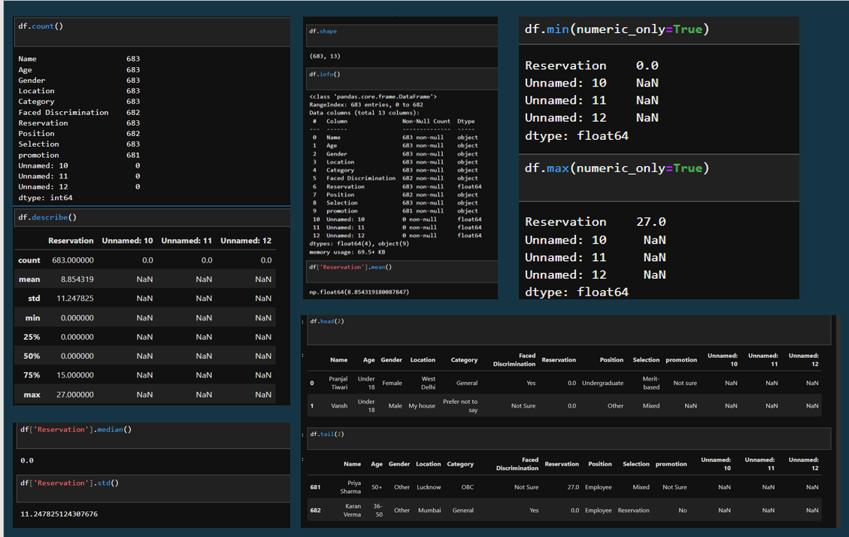

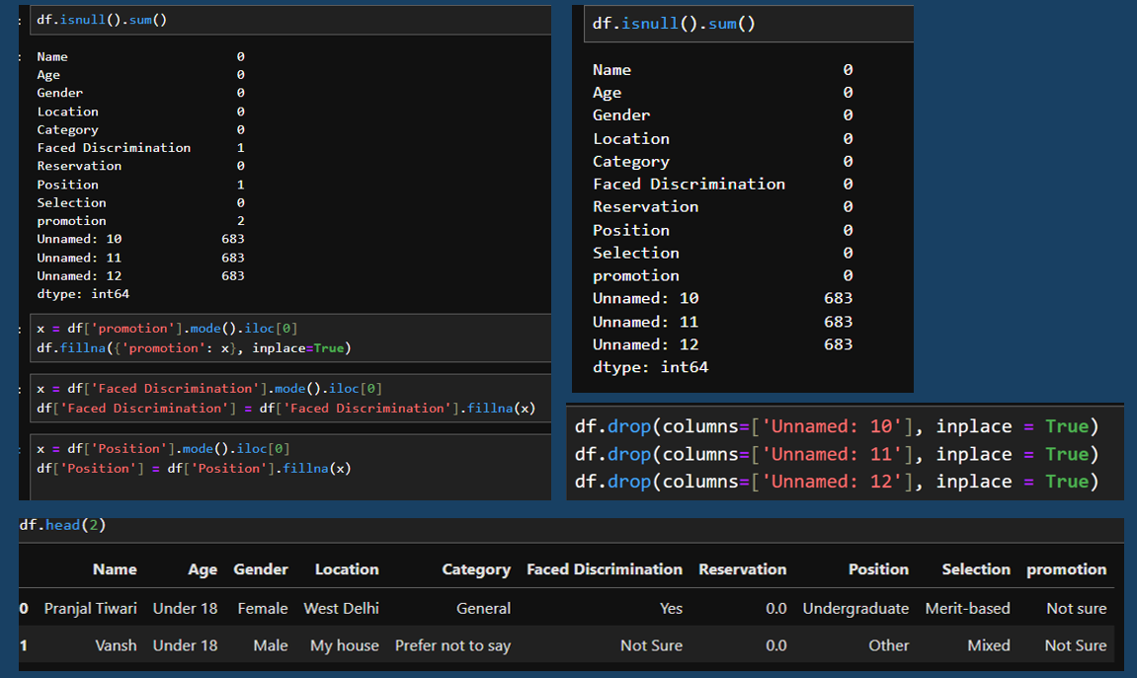

**Chapter 5:**

Matplotlib

**5.1 Introduction**

Matplotlib is one of the most widely used Python libraries for data visualization. It provides a comprehensive and flexible platform for creating a variety of static, animated, and interactive plots and charts. Developed as a 2D plotting library, Matplotlib supports line plots, bar charts, scatter plots, histograms, pie charts, error charts, 3D plotting, and much more. It is designed for ease of use while providing fine control over graphic elements, making it suitable for both simple exploratory data analysis and producing publication-quality figures.

The core of Matplotlib is its object-oriented API, allowing users to build complex visualizations by combining multiple plot elements such as figures, axes, lines, and labels. Its flexibility lets users create custom plots and tailor visualizations to their specific needs in data analytics, scientific research, business intelligence, and engineering fields.

**5.2 Basic Plotting**

Matplotlib’s basic plotting functions are intuitive and allow users to quickly visualize data.

* Line Plot: The simplest and most common visualization to show trends over intervals.

import matplotlib.pyplot as plt

# Plotting simple line graph with x and y values

plt.plot([1, 2, 3], [4, 5, 6])

plt.xlabel('X-axis Label')

plt.ylabel('Y-axis Label')

plt.title('Simple Line Plot')

plt.show()

This creates a line plot connecting points (1,4), (2,5), and (3,6).

* Bar Plot: Suitable for categorical data comparison.

plt.bar(['A', 'B', 'C'], [5, 7, 3])

plt.title('Bar Chart Example')

plt.show()

This plots bars for categories A, B, and C with respective heights 5, 7, and 3.

* Scatter Plot: Used to show the relationship or distribution between two numeric variables.

x = [5, 7, 8, 7, 2, 17, 2, 9]

y = [99, 86, 87, 88, 100, 86, 103, 87]

plt.scatter(x, y)

plt.title('Scatter Plot Example')

plt.show()

Scatter plots help detect correlations, clusters, or outliers.

* Histogram: A graphical representation of the distribution of numerical data by grouping data points into bins.

data = [1, 1, 2, 3, 3, 3, 4, 4, 5, 6, 7, 8, 8, 9, 10]

plt.hist(data, bins=5)

plt.title('Histogram Example')

plt.show()

Histograms are useful for observing underlying data frequency and distribution patterns.

**5.3 Customizing Plots**

Matplotlib allows detailed customization to improve the clarity and appearance of plots:

* Labels and Titles: Add descriptions to axes and a title for context.

plt.xlabel('X-axis Description')

plt.ylabel('Y-axis Description')

plt.title('Plot Title Example')

* Legends: Explain the different plotted data series for clarity.

plt.plot([1, 2, 3], label='Line 1')

plt.plot([3, 2, 1], label='Line 2')

plt.legend() # Displays the legend

* Colors and Styles: Customize colors, line styles, and markers to differentiate data.

plt.plot([1, 2, 3], color='red', linestyle='--', marker='o', label='Red Dashed Line')

plt.legend()

* Grid and Axis Limits: Add grids for better readability and adjust axis limits.

plt.grid(True)

plt.xlim(0, 5)

plt.ylim(0, 10)

* Ticks: Customize tick marks and labels on axes.

plt.xticks([1, 2, 3, 4, 5])

plt.yticks(range(0, 11, 2))

These options give users precise control over the plot’s look and feel to enhance data interpretation.

**5.4 Saving Figures**

Matplotlib allows saving visualizations in various formats like PNG, JPEG, SVG, PDF, etc. This is crucial for sharing, reporting, or embedding plots into presentations and documents.

plt.plot([1, 2, 3], [4, 5, 6])

plt.title('Sample Plot to Save')

plt.savefig('plot.png') # Saves current figure as 'plot.png'

You can specify resolution (DPI) and adjust the bounding box to save high-quality images.

**5.5 Integration**

Matplotlib integrates seamlessly with popular Python libraries like Pandas and NumPy. It can directly plot data stored in Pandas DataFrames or NumPy arrays, allowing analysts to combine data manipulation and visualization smoothly.

Example with Pandas:

import pandas as pd

data = {'Year': [2018, 2019, 2020, 2021],

'Sales': [250, 300, 400, 350]}

df = pd.DataFrame(data)

df.plot(x='Year', y='Sales', kind='line')

plt.title('Sales Over Years')

plt.show()

Example with NumPy:

import numpy as np

x = np.linspace(0, 10, 100)

y = np.sin(x)

plt.plot(x, y)

plt.title('Sine Wave')

plt.show()

This tight integration helps perform complete data analytics workflows from data ingestion to visualization using Python.

**Chapter 6:**

Seaborn

**6.1 Why Seaborn**

Seaborn is a powerful Python visualization library built on top of Matplotlib that simplifies the creation of attractive and informative statistical graphics. It provides a high-level interface for drawing attractive and informative statistical graphics with less code and better default styles. Seaborn enhances Matplotlib by offering more appealing color palettes, improved default aesthetics, and specialized plot types that are particularly useful for statistical data analysis. This makes it a preferred choice for data analysts and scientists who want to visualize data efficiently and meaningfully.

**6.2 Statistical Data Visualization**

Seaborn excels in creating statistical visualizations that help uncover patterns, relationships, and distributions within data. Two commonly used plots for statistical analysis include:

* **Heatmap:** A heatmap is a graphical representation of data where individual values are represented as colors. In data analytics, heatmaps are commonly used to visualize correlation matrices, which show the degree of linear relationships between variables. This helps in identifying multicollinearity, feature importance, or groupings in data.

import seaborn as sns

sns.heatmap(df.corr(), annot=True, cmap=`coolwarm`)

In the example above, the df.corr() calculates the correlation matrix of a DataFrame df, and Seaborn's heatmap visualizes it with annotations and a "coolwarm" color scheme for easy interpretation.

* **Pairplot:** The pairplot function allows you to visualize pairwise relationships across an entire dataframe. It generates scatterplots for numerical variables and histograms or KDE plots for univariate distributions, enabling a quick understanding of data distributions and interactions.

sns.pairplot(df)

**6.3 Advanced Plots**

Seaborn provides several advanced plots that are especially useful for deeper statistical insights:

* Boxplot: A boxplot (or whisker plot) displays the distribution of data based on five summary statistics: minimum, first quartile, median, third quartile, and maximum. It is useful for detecting outliers and comparing distributions across categories.

sns.boxplot(x='category_column', y='nummeric_value', data=df)

This plot helps compare how different categories vary in their numeric values and highlights any anomalies or outliers.

Other advanced Seaborn plots include violin plots, swarm plots, joint plots, and regression plots, which provide specialized insights into data distributions and relationships.

**6.4 Customization**

Seaborn allows extensive customization to make plots visually appealing and tailor them to specific needs:

* Color Palettes: Choose from predefined palettes such as "deep," "muted," "bright," or create custom palettes for consistent branding or thematic visualization.
* Themes: Easily switch between themes like "darkgrid," "whitegrid," "dark," "white," and "ticks" to change the background and grid style.

sns.set_style('whitegrid')

sns.set_palette('pastel')

* Advanced Customization: Modify axis labels, titles, legends, font sizes, and other elements using both Seaborn's API and Matplotlib's underlying functions.

These features enable creating polished, publication-quality visualizations with minimal effort.

**6.5 Seaborn vs Matplotlib**

While Matplotlib is a versatile and comprehensive plotting library offering fine-grained control, it often requires more code to produce aesthetically pleasing plots. Seaborn simplifies this by providing:

* Less Manual Configuration: Seaborn sets good default styles and color themes, reducing the need for manual tweaks.
* Statistical Plot Types: Ready-made plots for common statistical tasks like violin plots, pairplots, and heatmaps.
* Integration: Seaborn works well with Pandas DataFrames, allowing direct input of data with meaningful labels.

However, for fully customized plots or complex multi-axes figures, Matplotlib remains indispensable. In practice, Seaborn is often used in combination with Matplotlib to balance ease of use and customization.

**Chapter 7:**

Power BI

**7.1 Introduction**

Power BI is a powerful business analytics service developed by Microsoft. It provides interactive visualizations and business intelligence capabilities with an interface simple enough for end users to create their own reports and dashboards. Power BI allows organizations to transform raw data into insightful, actionable information through visually rich and dynamic reports, helping stakeholders make data-driven decisions quickly and effectively.

It integrates well with a wide variety of data sources and offers cloud-based and on-premises solutions, making it suitable for businesses of all sizes. Its features include data modeling, real-time dashboard updates, natural language querying, and collaborative sharing options.

**7.2 Connecting to Data**

Power BI supports seamless connection to a multitude of data sources, enabling analysts to bring data from diverse systems for unified analysis. Commonly connected sources include:

* Excel Files: Import Excel spreadsheets for quick analysis of tabular data.
* SQL Databases: Connect to databases such as Microsoft SQL Server, MySQL, or Oracle to import large datasets directly.
* Web Data Sources: Pull data from APIs or web services for real-time updates.
* Cloud Storage: Access data stored on Azure, Google Drive, or other cloud platforms.
* Other Sources: SharePoint lists, CSV files, and even social media platforms can be connected.

Once connected, the data is loaded into Power BI’s data model where it can be further manipulated and analyzed.

**7.3 Data Cleaning and Modeling**

Power BI includes powerful tools for cleaning and preparing data, often referred to as Power Query Editor. Users can:

* Remove Errors and Duplicates: Clean data by eliminating inconsistencies or duplicate records.
* Transform Data: Change data types, split columns, merge tables, and create calculated columns.
* Handle Missing Values: Replace or fill missing data intelligently.
* Create Relationships: Establish relationships between multiple tables through keys (primary and foreign keys) to create a well-structured data model.
* Define Measures and Columns: Write DAX (Data Analysis Expressions) formulas to create calculated measures and columns that enhance analysis.

This modeling phase prepares data for meaningful analysis and visualization by ensuring accuracy and relational integrity.

**7.4 Building Dashboards**

Power BI provides a user-friendly, drag-and-drop interface for creating interactive and dynamic dashboards:

* Visualizations: Choose from charts (bar, line, pie), maps, gauges, KPI indicators, tables, and custom visuals.
* Interactive Filters and Slicers: Users can interact with the dashboard by filtering data dynamically to drill down into details or view specific segments.
* Customizable Layouts: Arrange visuals to communicate a compelling story or insight.
* Tooltips and Drillthrough: Enhance user experience by adding hover-over tooltips or drillthrough buttons to explore data layers.
* Real-Time Updates: Dashboards can be configured to display real-time data, crucial for monitoring KPIs or operations.
* Sharing and Collaboration: Dashboards can be published to the Power BI service, shared securely with team members or embedded into other applications.

**7.5 Case Study: Sales Data Dashboard**

In a practical business scenario, a sales data dashboard was created using Power BI to help management track sales performance across regions and products.

* Data Connection: Sales data from an Excel file containing transactional details such as order date, product category, region, and sales amount was imported.
* Data Preparation: Cleaning was done to handle missing values and incorrect entries. Relationships were created between product and sales tables.
* Dashboard Features:
* Region-wise sales comparison using bar charts.
* Product category performance trends with line graphs.
* KPI cards displaying total sales, average order value, and monthly growth.
* Slicers allowing users to filter data by date range, region, and product.
* Outcome: This dashboard automated monthly reporting and provided real-time insights, enabling quick identification of high-performing regions and products, and supported strategic decision-making for marketing and inventory management.

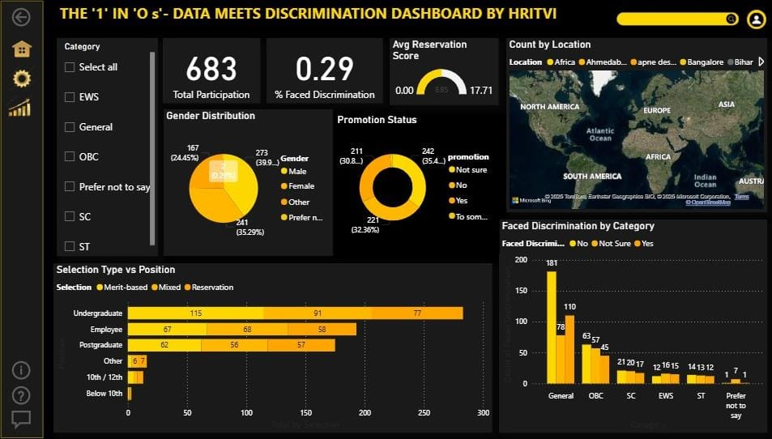

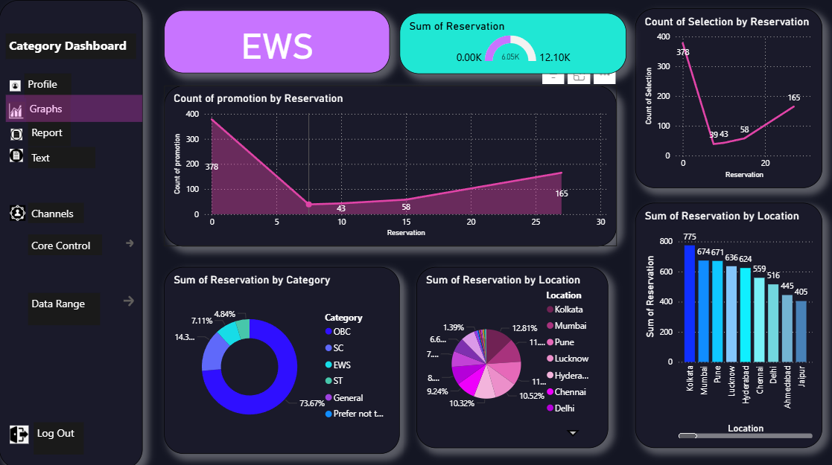

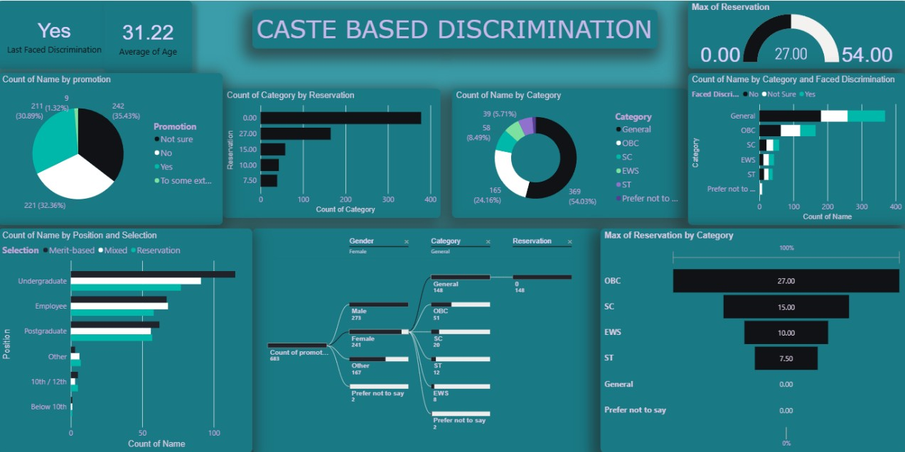

**Chapter 8:**

SQL

**8.1 Introduction**

SQL (Structured Query Language) is a standard programming language specifically designed for managing and manipulating relational databases. It enables users to create, read, update, and delete (CRUD) data stored in tables within a database. SQL is essential for data analysts as it facilitates efficient querying and handling of large datasets stored in relational database management systems (RDBMS) such as MySQL, PostgreSQL, Oracle, and SQL Server. It also plays a major role in data extraction and preprocessing during the analytics workflow, serving as a bridge between raw data and analytical tools.

**8.2 Database Concepts**

* Tables: A database organizes information in tables, which consist of rows and columns. Each row represents a record, and each column represents a field or attribute of that record. For example, an "Employees" table might have columns like EmployeeID, Name, Department, and Salary, with each row detailing a specific employee’s data.
* Relationships: Relational databases use relationships to link data across multiple tables. The key elements for establishing these links are:
  + - Primary Keys: A unique identifier for records in a table, such as EmployeeID in an Employees table.
    - Foreign Keys: A column in one table that references a primary key in another table to establish a relationship. For example, a Sales table may contain a CustomerID foreign key that points to the Customers table’s primary key.

These relationships allow for efficient data organization, minimizing redundancy and enabling complex queries across related data.

**8.3 Basic SQL Queries**

SQL queries are written to interact with the database. Here are examples of fundamental SQL commands:

* SELECT: Retrieves data from the database.

SELECT * FROM employees WHERE department = 'Sales';

This query fetches all records of employees working in the Sales department.

* INSERT: Adds new data into a table.

INSERT INTO employees (name, dept) VALUES ('John', 'IT');

Adds a new employee named John in the IT department.

* UPDATE: Modifies existing data in the table.

UPDATE employees SET salary = 50000 WHERE id = 1;

Updates the salary of the employee with ID 1 to 50,000.

* DELETE: Removes records from the table.

DELETE FROM employees WHERE id = 2;

Deletes the employee record with ID 2.

* 1. **Filtering, Aggregation, Joins**
* Filtering and Aggregation: SQL allows filtering records based on conditions and performing aggregate calculations.

SELECT department, COUNT(*) FROM employees GROUP BY department;

This query groups employees by department and counts the number of employees in each.

* Joins: Joins combine rows from two or more tables based on related columns.

SELECT * FROM sales s JOIN customers c ON s.cust_id = c.id;

This query joins the Sales table with the Customers table to show sales details alongside customer information.

Types of joins include INNER JOIN, LEFT JOIN, RIGHT JOIN, and FULL JOIN, each defining how data is matched and included.

**8.5 SQL in Analytics Workflow**

SQL is integral to analytics workflows because it helps in efficient data extraction and transformation before analysis. Analysts write SQL queries to:

* Extract relevant subsets of data from large databases.
* Aggregate and summarize data for reporting.
* Prepare data by joining tables and filtering noisy or irrelevant information.

The cleaned and structured data retrieved via SQL can then be imported into Python, Power BI, Excel, or other tools for further statistical analysis, visualization, and business intelligence reporting.

**Chapter 9:**

Excel

**9.1 Importance**

Excel continues to be a fundamental tool for data analysts due to its accessibility, user-friendly interface, and widespread adoption in business environments. It is often the first tool new analysts learn because it requires no programming knowledge and offers immediate visual feedback when working with data. Excel is versatile, suitable for quick data entry, simple calculations, and generating reports and charts. Many organizations rely on Excel for daily operations, making proficiency in it essential for business analytics, finance, marketing, and many other fields.

**9.2 Data Cleaning and Formatting**

Data cleaning and formatting are crucial steps in analytics, and Excel provides several features to make this process efficient:

* Removing Duplicates: Duplicate records can skew analysis results. Excel’s “Remove Duplicates” feature allows users to quickly identify and delete duplicate rows based on one or more columns.
* Data Validation: This feature ensures that the data entered into cells meets specific criteria, such as restricting entries to a list of values, dates within a range, or numbers within limits. Data validation reduces entry errors and maintains data integrity.

Other useful cleaning features include trimming extra spaces, converting text cases, and using conditional formatting to highlight anomalies or outliers in the data.

**9.3 Functions & Formulas**

Excel provides a vast library of built-in functions and formulas that simplify data manipulation and analysis:

* VLOOKUP (Vertical Lookup): Searches for a value in the first column of a table and returns a value in the same row from a specified column.

Example:

=VLOOKUP("Product1", A1:B10, 2, FALSE)

This formula looks for "Product1" in the range A1:A10 and returns the corresponding value from the second column.

* IF: Performs logical tests and returns one value if true and another if false.
* SUMIF: Adds up numbers based on a condition or criteria.
* COUNTIF: Counts the number of cells that meet a certain condition.

These functions enable analysts to automate decisions, filter relevant data, and aggregate results efficiently without manual calculations.

**9.4 PivotTables & Charts**

* PivotTables: PivotTables are powerful tools in Excel that allow users to summarize, analyze, explore, and present data quickly. They help in aggregating large datasets by categories, calculating sums, averages, counts, and other statistics in a tabular format. PivotTables support drag-and-drop ease to reorganize data dynamically.
* Charts: Excel offers a wide range of chart types—bar, line, pie, scatter, and more—to visualize data trends and comparisons effectively. Charts created from PivotTables are interactive and update automatically with the underlying data.

PivotTables and charts together provide interactive data exploration capabilities, enabling quick decision-making by revealing meaningful patterns and trends.

**9.5 Excel vs. Other Tools**

Excel excels in handling small-to-medium data sizes and is ideal for quick reporting and ad hoc analysis tasks due to its easy learning curve and instant visualizations. However, when working with large datasets, complex data models, or when automating repeated analysis workflows, Python, Power BI, and SQL are preferred for their scalability, advanced analytics capabilities, and integration features.

* Python is preferred for scripting custom data processes, advanced statistical analysis, and machine learning workflows.
* Power BI offers sophisticated BI dashboards and real-time data connectivity.
* SQL is essential for managing and querying large databases efficiently.

Still, Excel remains a core proficiency for all aspiring data analysts as a convenient starting point and a complementary tool within the analytics ecosystem.

**Chapter 10:**

Conclusion

**10.1 Key Learnings**

During this summer training, I gained substantial hands-on experience with essential data analytics tools and techniques. I learned to handle all stages of the analytics process—from cleaning raw data, conducting thorough analysis, to creating insightful visualizations. Specifically, I developed strong proficiency in Python programming and its powerful libraries such as Pandas for data manipulation, NumPy for numerical computations, and Matplotlib and Seaborn for visualization. I also enhanced my SQL skills for database querying and learned to create interactive, dynamic dashboards using Power BI, enabling effective business intelligence reporting. Additionally, I leveraged Microsoft Excel not only for basic analytics but also for applying advanced functions and formulas, which remain critical for quick data exploration and small-to-medium dataset analysis.

**10.2 Applications**

The skills and knowledge acquired from this training have prepared me for various professional roles in the data analytics domain. These include business analytics, where data-driven decision-making is key; data science, encompassing advanced predictive modeling; finance, requiring detailed data scrutiny for forecasting and risk assessment; and consulting, which demands actionable insights for diverse industries. Overall, the training has equipped me to contribute effectively in any field that relies on data for competitive advantage and operational excellence.

**10.3 Further Study**

To build on the foundation gained, I plan to pursue further learning in several advanced areas of data analytics:

* Advanced Machine Learning: Deepening understanding of algorithms, neural networks, and AI to build predictive and prescriptive models.
* Data Engineering (ETL): Gaining expertise in designing robust pipelines for extracting, transforming, and loading data to ensure scalable analytics systems.
* Cloud Platforms (Azure, AWS): Acquiring skills to manage, process, and analyze big data in cloud environments, taking advantage of distributed computing and storage solutions.

These areas will enhance my ability to handle larger datasets, perform more complex analyses, and deploy solutions in modern, scalable infrastructures.

**10.4 Personal Reflection**

This summer training has been a transformational experience that bridged the gap between academic theory and practical industry applications. Working on real datasets and tools has strengthened my confidence in addressing real-world data challenges. The comprehensive exposure to various analytics tools and workflows has motivated me to continue advancing my expertise in this fast-evolving field. I am excited about the future opportunities where I can apply these skills to solve meaningful problems and drive data-informed decision-making.